Assignment 1 - Building A Game World

**[Desert Vault]**

[Name:Zhaomin Liu]

[Student ID:32229763]

# 

**Character Design 2**

Character 1 - [Vahan Neal] 2

Character 2 - [Alice Cortez] 4

Character 3 - [Todd Cortez] 6

Character 4 - [Micheal Summers] 8

Character 5 - ["Client 09"] 10

**Narrative Design** 12

Narrative Genre: 12

Setting: 12

Act 1: 12

A Contract: 12

Knowing the first Ally: 12

Contacting a friend: 13

Exploring the Excavation: 13

Act 2: 14

Meeting the Mentor 14

Earning the trust of Mentor 14

Learning Skills from the Mentor: 15

Investigation: 15

Entering the Desert Vault: 16

The Battle: 17

The Truth: 17

Act 3: 17

A Hard Desicion: 17

Reversing: 18

Return home: 18

**Critical Analysis** 19

Character Archetypes: 19

Narrative Tropes: 19

Stereotypes and Cliches: 20

Show Don’t Tell: 20

Genre Conventions: 21

# Character Design

## Character 1 - [Vahan Neal]

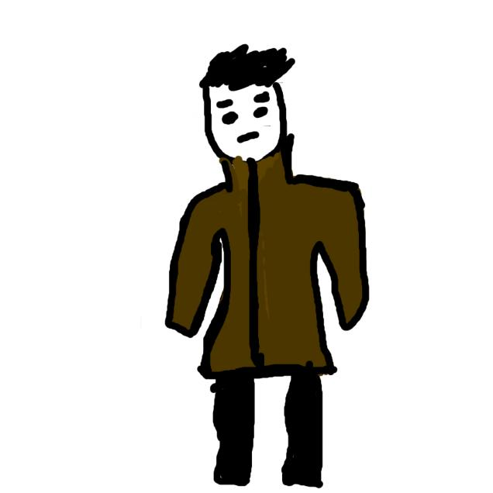

**Name:** [Vahan Neal]

**Age:** [22]

**Gender Identity:** [Male]

**Archetype:** [Hero]

**Appearance:**

Vahan was of medium height but very strong with black hair and white skin.He usually wears a brown windbreaker and a hat.And he always bring his notebook and pistol.Vahan is a cautious and calm person.

**Background:**

Vahan born in a small city near the edge of the galaxy.He learned a lot of skills from his father.His father was a excellent killer but retired after Vahan’s birth.Vahan learned about how to use guns,knife and environment.His father also influenced him to become a realistic and cautious person,but he will show kindness to people.

He is good at fight and research now,university education gave him rich knowledge as a detective.He chose to become a detective due to the dangerous environment over the galaxy.Private detectives are needed everyday,Vahan can always find some tasks.But he is a new to the detective industry,he may need more time.

Micheal Summers is familiar with Vahan because of the intelligence trading.By Micheal’s help,Vahan found the person who killed the creator of “Desert Eye” and earned the trust of “Desert Eye”.With the storyline,Alice will become the girl friend of Vahan.”Client 09” is the main enemy of Vahan.

Vahan is hired by a company called “Desert Eye” as a private detective now.”Desert Eye” is a huge company which controls many areas over the galaxy,they want Vahan to investigate an excavation area.This area caused many people died and something evil inside.The excavation area just near the T2 city,which is a city he familiar with.

**Goals:**

At first,Vahan’s goal is finish the task from “Desert Eye” and make the excavation area safe like before.But after he knew that “Client 09” want to use the machine inside the vault and a device to reverse the world.His goal is stopping “Client 09” and destroying machine and device.

**Flaws:**

## Vahan’s flaws are obvious,he is not good at negotiation.Every time Michael wants more payment,he has to agree.

## Character 2 - [Alice Cortez]

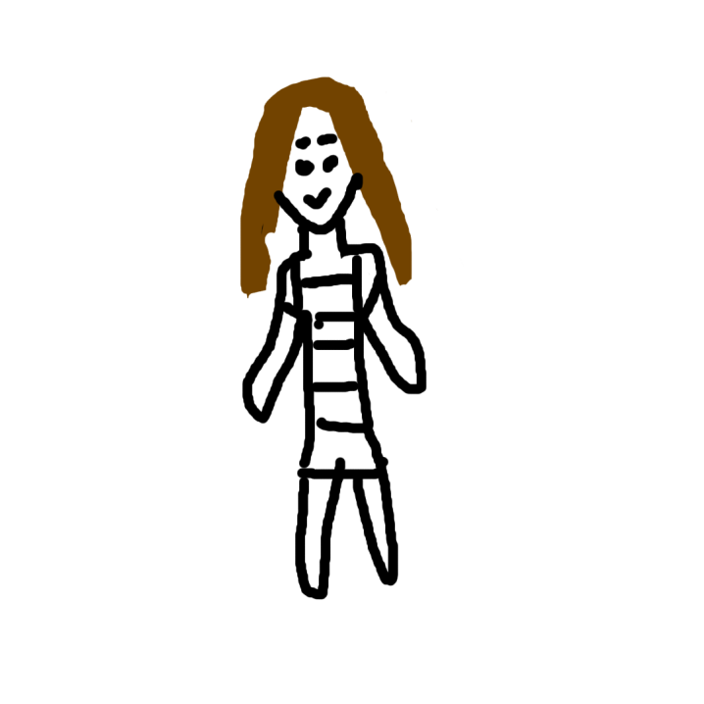

**Name:** [Alice Cortez]

**Age:** [20]

**Gender Identity:** [Female]

**Archetype:** [Ally]

**Appearance:**

Alice is tall and thin with brown hair and white skin.She is beautiful and kind, always wants to help teammates.She usually wears formal clothing due to the family education.

**Background:**

Alice born in T2 city near the desert,she is a young researcher.Her mother passed away when she was 8 years old and her father brought her up.She is good at using many tools and new technology.Her family arrived this planet 300 years ago and built the first settlement area.That area became the T2 city 100 years ago, and her family controlled a lot of things in this city by cooperation with Desert Eye.

Reading is Alice’s favorite thing.Her father opened the family library for her.Alice loves old books from her family collection,she often read that and learned knowledge about how her family built the settlement area.Her ancestors opened a desert vault 200 years ago and many people died,then they sealed it and moved the settlement area far from the vault.But she didn’t find any information about what inside the vault,that made her so curious about the vault.She tried to ask her father but Todd refused to talk about that.But Alice peeked her father’s file and became more curious about that vault.Her father’s file confirms the authenticity of vault.

She met the Vahan in a bar,Vahan talked about the excavation area with others.She was very curious about that,so she wanted to become a teammate of Vahan.She believe that the desert vault must under that excavation are.But Vahan was cautious and refused Alice at first,then left the bar.But Alice found Vahan again in a park and gave him a book about desert vault.Alice tried to make Vahan believe this vault under the excavation area.

**Goals:**

Alice had only one goal at first,she wanted to know what was inside the vault.But after she knew the excavation accident,she also wants to find the reason and stopping the Daniel’s reversing plan.

**Flaws:**

Alice is too kind and naive due to her family protection.And she almost have no ability to fight with other.

## 

## Character 3 - [Todd Cortez]

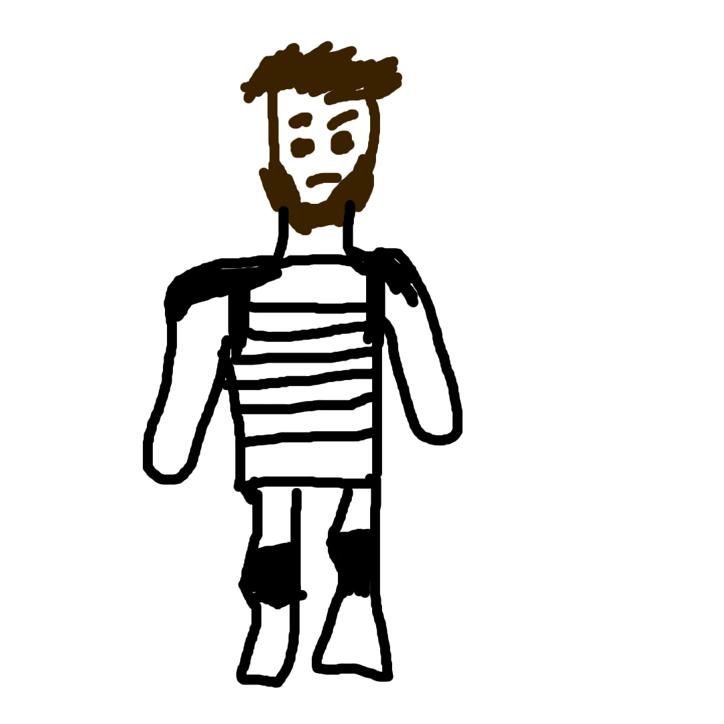

**Name:** [Todd Cortez]

**Age:** [50]

**Gender Identity:** [Male]

**Archetype:** [Mentor]

**Appearance:**

Todd is tall and strong with brown hair and skin,he is serious and refuses to communicate with strangers.And he always wants to protect his daughter,Alice.

He usually wears protective clothing with a bulletproof insert plate.

**Background:**

Todd also born in T2 and he was the best technologist in this city with many students,which helped his family to keep influence.Todd started to learn the particle collider when he was just 15 years old and he is a genius.What’s more,he also learned combat skills to protect himself.Todd entered the vault before Alice’s birth,and he collected a lot of things to do the research.Technology inside the vault helped Todd building his lab.

Todd got married with a kind woman and her gave birth to Alice.But she passed away just 8 years later.Todd was very sorrowful and opened family library for Alice to comfort her.Then he continued his research about vault technology.He opened a secret portal for many times and recorded that,which attracted his best student: Daniel Mason.This portal may lead people to another world.

About 5 years ago,Todd’s lab had a explosion and he lost Daniel.He cannot accept and left the lab.Todd also prevent Alice from any knowledge about Technology in his lab.But he forgot old books about vault in family library.Now Todd also knows the thing about excavation area and trying to prevent Alice entering there.Because he also felt some connections between vault and excavation area.But after he knows that some students of him died in excavation area,he wants someone to solve this problem.

With the storyline,Todd will accept Vahan and become his mentor,teaching Vahan some new skills and abilities.

**Goals:**

Todd just wants to protect Alice at first.After he knew that many students of him died in excavation area,he wants to find out the reason.

**Flaws:**

Most of the time, Todd is a very calm person.But he is too difficult to communicate for now.He trusts no one but his daughter.

## 

## Character 4 - [Michael Summers]



**Name:** [Michael Summers]

**Age:** [30]

**Gender Identity:** [Male]

**Archetype:** [Shapeshifter]

**Appearance:**

Michael was of medium height and thin.His hair is black and skin is brown.He is an intelligence agent,always cunning and calm for any contract.He can betray anyone for benefit.

**Background:**

Michael born in a very far planet called VH2,his parent died when he was very young.He survived by himself.So he can adapt many different environments.He was worker,drone manager,killer and private agent.3 years ago he became a intelligence agent and his first client wanted to buy intelligence about Desert Eye.He refused the client by safety reason,then that client almost killed him.He was lucky that bullet didn’t hit the heart.But after that he had to move to T2 city and hiding his whereabouts.

Vahan usually enters the T2 city for tasks. Michael heard about this young detective, he was aware of the new opportunity.Intelligence is very important for a detective. Michael contacted Vahan,but Vahan was cautious and refused him at first.

1 year ago,Vahan was in a difficult mission.He had to investigate who killed the creator of Desert Eye.He almost had no information about the killer.Then Michael contacted him again and gave him a file.This file includes the recording of creator’s whereabouts in 5 days and the criminal stronghold nearby.By the recording, Vahan found the killer easily and shared 50% reward with Micheal. Then they became “friend”.

Micheal met the “Client 09” 3 months ago.This client wants to buy any information about “micro black hole” but refuses to give the objective. Unfortunately,Micheal just knew a little about that.However,”Client 09” didn’t gave up.He still contacting Micheal and asking for more.

**Goals:**

Michael has only one goal,earning more money and retiring.Intelligence agent is too dangerous.

**Flaws:**

Michael is a double-dealer and he is too self-confident,which made him in danger many times.

## 

## Character 5 - [“Client 09”Daniel Mason]

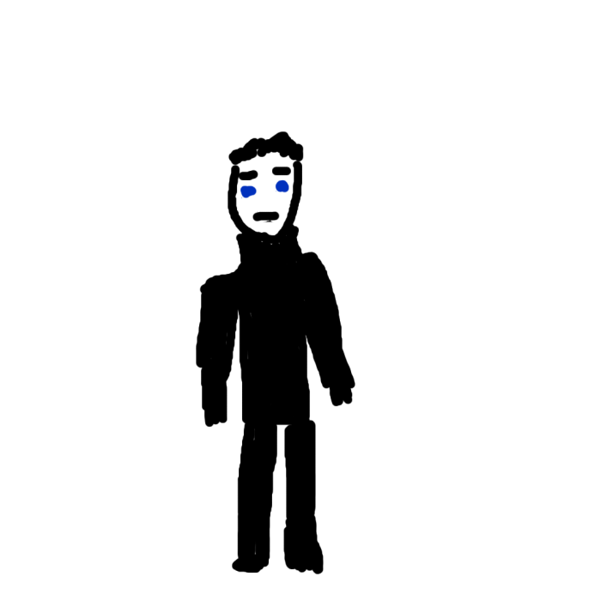

**Name:** [“Client 09”Daniel Mason]

**Age:** [33]

**Gender Identity:** [Male]

**Archetype:** [Enemy]

**Appearance:**

Client 09 is a secret client of Micheal Summers.He usually wears black clothing.He is serious and silent,never talking about himself to stranger.

**Background:**

Daniel Mason was born in a small village near the T2 city.When he was young,he got a worn-out book from an old man.This book is an explorer’s journal,records many interesting trips.Last trip in this book impressed Daniel mostly, that is desert vault.

”We found a huge gate near sand hill,it is not far from settlement area.”The book said”This gate is beautiful,I never know any art style like this before.It is a totally new discovery!But local people warned us when we want to talk about that,they called it desert vault and this vault can kill people.But I cannot ignore it,we want to enter it.At least we need to take some photos in it.”

That explorer opened the gate and entered the vault with his team ,they found many strange statues and a huge machine,then the journal stopped.At the end,explorer said he listened whisper and opened the machine.That machine opened a portal.After reading this book, a voice started to talk with Daniel.Actually,this is a corrupted book.

At first,this voice had no big influence to Daniel.It was a soft woman voice,not annoying at all.1 year later, the voice started to influence him and try to control him.He resisted for few months but that voice was too powerful to resist.Then Daniel became the voice’s tool.This voice is an ancient soul, its body had been destroyed and now it became a part of Daniel.

The voice want to reverse the galaxy and back to its age,which will destroy today’s world.It belong to the age about 10000 years ago,they are the original people in this planets and they had advanced technology.But a disaster destroyed its world and eliminated almost all marks they left.The voice kept its mind by machine and entered the journal.Todd didn’t touch the journal so the voice cannot influence him.The voice loves its people,destroying today’s world will makes its suffer but acceptable.Its original world must be saved.To reverse time,it needs another device called “micro black hole” which is still no actual location.This one also built by the voice.

Then Daniel entered the Cortez Lab as an excellent researcher by voice’s knowledge.Voice told him to investigate carefully.After Todd opened the portal,Daniel made a mistake intentionally and explosion built a big portal.But his teammate found his crime.He have to kill him and jumped into the portal.

Portal led Daniel to the training place which built the voice,Daniel learned a lot of voice’s technology and he totally became the voice.Then portal transported Daniel to 7 years ago and killed Alice’s mother by another identity:”TUH57”.The voice believes that Alice’s mother has information about “micro black hole”,and it found nothing.Now voice and Daniel are one,Daniel’s original mind had been destroyed.The accident in excavation made by him, and he usually lives in vault now.He will find the blueprint of “micro black hole”.

**Goals:**

Destroying today’s world and reversing the galaxy to its age.

**Flaws:**

Daniel’s body is not strong,he depends on the weapons in battle totally.The voice wanted to enhance him but he cannot undertake that.The training just teaches him about weapons.

# 

# Narrative Design

## Narrative Genre:

My game is a sci-fi game that includes space travelling and future technology.

## Setting:

About 2500s,human have the space travel technology and built settlement areas all over the galaxy.But no government can manage those areas.To solve accidents and crimes,private detectives became a popular industry.Our main character Vahan is one of them.Story begins at Vahan’s house in a small city,but main part of this story takes place on T2 city and Desert Vault.

## Act 1:

### A Contract:

An emergency email from a familiar number wakes Vahan up.This is a contract from “Desert Eye” with Holographic projection.Vahan cooperated with them last year,this company is generous.

Manager of the “Desert Eye” told Vahan that they lost about 50 workers last night in an excavation area near the T2 city,a huge portal ate them and the residual radiation also caused many people died.Their military experts cannot handle it,now they want Vahan to investigate this area and find the reason.

Vahan wanted to refuse such a confusing contract.But after he watched the news,he is so curious about that excavation and he also needs more money for a new space ship.Then he accepts the contract.

### Knowing the first Ally:

Vahan enters the T2 city but his first station is not excavation area.This is a confusing contract and he has to investigate more in a familiar bar.He sits down near the bar counter and listens people talking.Someone mentioned excavation area, Vahan moves closer to them and tries to ask about that.They are lucky workers in the excavation area.At that night,they uncovered a huge gate and then the portal presented. A young lady listens their talking and she want to talk with Vahan.Her name is Alice and she is a researcher.She tells Vahan a vault near the T2 city and she believes that vault must under the excavation area.Vahan wants to keep distance from Alice,she is strange and enthusiastic.Then Vahan leaves the bar and goes to central park, but still no more information.

Alice finds Vahan again near the gate and gives him a book about desert vault,Vahan have no choice but listening her objective.By talking, Vahan finds that Alice has no malice and very kind.Alice wants to become his teammate and enters the excavation area to find the vault,which makes Vahan hesitant.He never need teammates due to the dangerous job.But Alice is too stubborn, Vahan has to accept Alice temporarily and goes back to hotel.Alice goes back to home jolly.

### Contacting a friend:

Vahan enters his room and opens the cell pad,he still needs more information before going to the excavation area.Alice’s assumption cannot be taken as intelligence.And Vahan never plans to go to the excavation area with Alice.

Except the vault story,Vahan needs more actual information about who related to this accident.Those workers in the bar cannot give him more,Vahan has to contact his “friend” Michael Summers.

Michael cooperated with Vahan last year,he is a clever intelligence agent.Vahan wants to buy intelligence about excavation area,Micheal gives him the manager of excavation area and a name called “Todd Cortez”.Micheal says Todd was the best researcher in T2 city and he knew the vault very well.If Vahan wants to know more,he needs to take some photos in excavation area and visiting Todd.

At the end of contacting,Micheal wants higher payment for this intelligence.Vahan knows he cannot negotiate with Michael,then agrees it.

**Exploring the Excavation:**

Vahan contacts the manager of “Desert Eye” and he gives Vahan location and license to enter the excavation area.

This place is locked by “Desert Eye”,they wished to build new houses and extending the T2 city.Vahan wears protective clothing and steps into it.He cleans the sand out and finds some unreadable words on floor.Then he sees a big hole,he looks down through the hole and sees a huge gate and 2 broken statues with strange symbol.He feels bad,this gate looks like the way to hell.Vahan remembers Alice’s book,which also mentioned a huge gate with 2 statues.He wants to give this contract up now,but “Desert Eye” won’t accept.And he feels pity to those workers,kindness inside him won’t allow giving up

He decides to visit Todd Cortez at first.

## Act 2:

### Meeting the Mentor:

Vahan finds Cortez’s house easily but he has no way to enter.A familiar voice in house said she recognizes him, and a door is opened.Alice walks out and invites him in.Vahan is surprised and tells Alice that he needs to talk to Todd Cortez.And he knows that Todd is Alice’s father.

Todd sits in garden,he is cleaning a old rifle.Vahan move closer with Alice and shows his respect.Todd doesn’t like this visitor.Vahan says he wants to know more about desert vault,which makes Todd angry and nervous.Then Todd asks Alice to send Vahan out,Vahan even has no chance to show photos.Alice and Vahan leave the house,Vahan has to show photos to Alice and tries to get a confirmation.Alice is surprised and tells Vahan a secret,Todd researched the things from desert vault for many years.The strange ruins under the excavation area is the desert vault,the gate in photo is the entrance.

Vahan accepts Alice as a teammate formally after the confirmation,he has no other choices.To finish the contract,Alice’s help will be necessary.But Alice says that her father won’t allow her becoming the teammate of Vahan.If Vahan can solve a difficult problem of Todd,he can accept Vahan.

**Earning the Trust of Mentor:**

Alice tells Vahan that Todd believes Alice’s mother was killed by a killer called TUH57,killer’s target was Todd but he made a wrong decision.Todd started to find TUH57 12 years ago but still no result.If Vahan can find THU57,and make him suffer retribution should make Todd feeling better.

This is a difficult extra task,12 years have passed and Vahan never heard about this TUH57.He contacts Michael firstly but Michael has no information about TUH57.Fortunately,Vahan’s father was a killer,he tells Vahan that TUH57 retired about 5 years ago.TUH57’s real name is Jason Hinton,he was a teammate of Vahan’s father.But he was too cruel and emotionless,Vahan’s father left that team just 1 month later after the joining.TUH57 living in an area in the central city of galaxy now.

Vahan buys a license from Michael and enters the central city.He finds TUH57 easily,but TUH57 says he didn’t kill anyone 12 years ago.He provides proof to Vahan shows that Alice’s mother died in an accident,Vahan doesn’t want to trust him but he cannot kill here.Then he brings proof back to Alice.

### Learning skills from Mentor:

To Vahan surprise,Todd feels much easier after looking through the proof.Now he believes that his wife was not murdered.After all this years,he gets his result.Todd changes his mind,he can share more information with Vahan now.But he still doesn’t allow Alice to be involved.

Todd tells Vahan the vault under the excavation area was built by another civilization about 10000 years ago,but such advance technology may comes from future.He is confused about that.The portal which caused many people died should be very similar to the portal in Todd’s lab,the vault must be activated by someone again.If Vahan wants to solve the contract,he needs to enter the vault.Another reason Todd wants to offer help,is some of Todd’s students also died with those workers.He also wants a result for that.

The desert vault has a security system.If Vahan really wants to enter the vault,he needs a protective clothing.Todd will give Vahan a new protective clothing as reward, and plans to tech Vahan about how to deal with the things in vault.First kind of enemy is small robots,they are not difficult to break.Todd’s team cleaned them easily.Another enemy is big drone,Todd brought some parts of it back to lab,it is dangerous.This drone has a self-repair system,you must destroy the core to kill it.What’s more,all statues can become enemies,they are difficult to deal with.

Todd opens his lab and shows his research to Vahan,he teaches Vahan to use his weapons.Those weapons are made by vault technology,Vahan needs such weapons.Todd warns Vahan not entering the portal for any time,the portal can create unstable time flow and killing people.After 3 months learning,Vahan gets all knowledge Todd knows.Todd teaches him about weapons, device to translate ancient language and how to survive in vault.But Todd didn’t go to the deep part inside the vault,Vahan may face something unexpected.

**Investigation:**

Todd suggests Vahan to know more about the vault,he heard that central library’s collection includes some strange books with same symbol as the vault.Vahan should go to check that.

Vahan enters the central library and finds those books easily.The book has the same words as excavation floor,but Vahan can read some of them thanks to Todd’s device.It says that “we” built a machine called T7S,it can create unstable time flow and transporting people to other ages.But this portal needs authorized people to operate,other cannot teach it.This portal is “our world”’s insurance mechanism,”we” can use this to reverse the time and rebuilding our world.But this step needs 3 keys: authorized people,T7S and “micro black hole”.”Micro black hole” can make sure that “we” can reverse such long time and rebuilding our age correctly.The blueprint of ”micro black hole” was saved in “machine vault”.

A man with black clothing approaches Vahan,he picks up a pistol.Thanks to Todd’s device,first shoot missed him.This man is silent and scary,Vahan hides between bookshelf and tries to fight back.The man is angry,he says all people who read that book must die.Then he burns up the library and brings the book out.Vahan doesn’t chase after him,he has to escape from this library now.

After Vahan escaping from library,Michael contacts him.Michael says the man who attacked Vahan is one of his client,code 09.He doesn’t want to lose Vahan,so he offers this intelligence by free.And he hates this client 09,he is annoying and strange.He just finds the information of him,his name is Daniel Mason and he should die 5 years ago.He was a researcher in Cortez Lab,Vahan should contact Todd again.

Todd feels bad after received this message,the man in holographic projection must be Daniel Mason but he doesn’t want to believe.Vahan and Michael infer that “Daniel” is living in the vault,Michael said he often enters the excavation area and then disappear.Todd makes a decision,he will enter the vault with Vahan.He wants to meet his student and find everything out.

### Entering the Desert Vault:

Todd activates his spaceship with Vahan and travels to the excavation area.After they arrived, Alice jumps out from a big box.She also wants to enter the vault but her father won’t agree,she has to hide herself at first.

Todd is angry but he accepts Alice’s choice,he cannot hide this to Alice forever.Vahan is a little bit glad,he likes Alice.They go down to the gate by jet packs.The gate opens itself automatically,a road with statues is shown to them.No robots, no drone,just silence here.Todd and Vahan feel uncomfortable,it might be a trap.But the broken floor is sealed up by something,they have no way back.

They have to move forward, and they hear the voice of Daniel.Daniel wants to reverse the time to “their” age just like what the book said.And he invites them as teammates,they will be authorized and survive when Daniel reversing time.Vahan cannot accept this and shoots the sound drone down.Then a lot of drone come up and starting to attack them.Vahan finds the spear on statues can break drone easily even he didn’t hit the core.3 people break all drones easily and keep going.

This vault is not that big,they find the control room soon and Daniel is in there.

### The battle:

Daniel has finished “micro black hole” and trying to activate it.Vahan shoots his hand but Daniel recovers immediately.Daniel still wants Vahan,Todd and Alice to surrender,but they won’t accept.But Daniel’s weapon is too powerful,they cannot hurt him.At this time,Alice finds that Daniel needs power battery to to keep his protection.Todd and Vahan break the battery near the corner,but Todd’s leg is shot by Daniel.He cannot move now.Vahan finds that Daniel is weaker but still recovering,and his weapon still powerful.

Vahan finds the device of Daniel has a limitation,so he uses Todd’s weapon with same energy to overcharge Daniel’s device and an explosion breaks Daniel.Without protection and Weapon,he is just a normal man and Vahan defeat him easily.But the explosion also charged the “micro black hole”.

### The Truth:

Daniel sits near the table,explosion hurts him heavily.At his last moment,his original mind takes the control back and the voice leaves.He tells Todd that he never know the real Daniel,he was controlled by voice before entering Cortez Lab.The explosion and excavation accident made by him,and the killer of Alice’s mother is him.He feels sorry even that was not true Daniel.Todd feels angry at first but then keeps silence.He is shocked by the truth and doesn’t know what should to say.

**Act 3:**

### A Hard Decision:

By the last breath,Daniel tells Todd that “micro black hole” was activated by explosion energy.The reversing process has been started.If they want to stop this,sacrificing is unavoidable.A person must jump into the portal after its show up and reverse to T2 city 12 years ago,finds the Daniel and kill him before he finding Alice’s mother.Then Daniel won’t exist and the voice cannot finish the reversing plan.But that voice left him now,no one can be authorized when going through the portal.Without authorization,people will die in portal after 2 hours and they cannot go back once steps into the portal.

After a short silence,Vahan moves closer to the portal.Todd and Alice want to stop him,but Vahan refuses them.Todd wants to go to the portal but his leg is broken,Alice wants to enter the portal but Vahan locks her up by Todd’s weapon.

**Reversing:**

At first,Vahan just wanted to earn money and he even wants to give up the contract.But now it is not contract,he needs to save the world.He is regretful and afraid actually,but he has to do this.

He jumps into the black portal and outside world already started to collapse.He set the time to 12 years ago and arrives the spaceship station where Alice’s mother died.Daniel already there and Alice’s mother hasn’t show up.Vahan moves closer to Daniel,Daniel feels the threat and wants to run away.Vahan starts to chase him,but his body already started to collapse.Fortunately,Daniel cannot go too far from the transport point due to the incomplete machine.Vahan killed him easily.

### Return home:

Vahan feels that his body is collapsing,he has only 40 minutes left.He has no chance to say goodbye to his father,but he can go back to home now.At this timeline,he just about 10 years old.He wants to see home last time,so he find a spaceship and goes back to home.He has 15 minutes left after reached the home.

He cannot enter the house,but watches himself and father at far distance is enough.Then he disappears like sand.And he sees an unknown world,a man with same symbol as vault is playing with children.His voice is so close to the Daniel.

Alice and Todd are sorrowful,they buried Daniel and their world back to normal.Desert Vault is not dangerous now,Todd destroyed all things in it and sealed it forever.Then brought his daughter back to home.Alice deals the things after Vahan’s death.Todd hosts Vahan’s funeral and Michael is so disappoint about this news,he lost a stable income.

3 years later,Alice rebuilds Cortez Lab and changes the researcher area to memory recovery.A normal morning,Alice is testing her new device and she listens a familiar voice.That is Vahan’s voice.....

# Critical Analysis

## Character Archetypes:

Act 1 includes Vahan as hero,Alice as Ally and Micheal as Shapehifter. Vahan is my hero character,so the story begins by him.And others will be led out by Vahan’s action.Alice is my Ally character and she is led out by Vahan’s action in bar.As an ally,she always want to help Vahan and offers him some useful information.Micheal is shapeshifter,he will help Vahan but also wants more payment from him.He is not a real friend or enemy.

Act 2 includes Vahan as hero,Alice as Ally,Micheal as Shapehifter,Todd as Mentor and Daniel as Enemy. As the hero,Vahan is still the core of my story.Most of the actions focusing on Vahan at this part,he defeats the drones and Daniel inside the vault. Alice helps Vahan to be accepted by Todd,proves that she is still a good ally.And she is clever,helps team to find enemy’s weakness. Todd as Mentor teaches Vahan a lot of skills and weapons,he also defeats the Daniel and finds out truth with Alice and Vahan.Michael as shapeshifter helps Vahan by free for bigger benefit.As the enemy,Daniel first shows up is attacking Daniel and he even burns the library which caused many people died.Then he tries to reversing the time and destroying today’s world.

Act 3 includes Vahan as hero,Alice as Ally,Micheal as Shapehifter,Todd as Mentor and Daniel as Enemy.As our hero character,Vahan made the hard decision and sacrifices himself to save the world.As the Ally,Alice solves a lot of Vahan’s things about family,contract and payment.Todd hosts Vahan’s funeral as his Mentor.For Michael,he never feel sorrowful but just disappoint.Which fits Michael more to shapeshifter.

## Narrative Tropes:

**Sidekicks:** Alice is that sidekick one who always support Vahan.She offers useful information and enemy’s weakness.

# **From Zero to Hero**: At the beginning of my story,Vahan is a young detective who just finished a little contracts.At the end of my story,Vahan becomes a hero who saves the world.

# **A True Hero:** Vahan is not perfect.He just wants some money at first and not so brave.

**Cops and Detectives:** Vahan is a detective and most of his contracts about dealing with crimes.

**Action Dads:** Todd is Alice’s father and he is good at vault technology,but he never told Alice before.

**Naive Everygirl:** Alice is a very naive and kind girl.She is sincere and easy to trust others.

## Stereotypes and Cliches:

**Stereotypes**

I avoided writing my hero character to a perfect one.A perfect hero who brave,kind and selfless is a kind of boring stereotype.For my hero Vahan,he is realistic and cautious.Vahan is not selfless,he will feel regret and afraid when he sacrificing him to save the world.But he is kind,he made the choice even he is afraid of death.

I also avoided writing my mentor character to a normal mentor.Todd is not a selfless mentor,students need to earn his trust and offer the benefit.But Todd really care about his students.

**Cliches**

I didn’t write a normal hero story that hero have good teammates and people’s support then defeat the evil and gets happy life.

In my hero story,each things have to be earned by self.Vahan earns his ally Alice by trust her,then earns the trust of mentor by investigation.Each things are not easy,each one has their own purpose.Another reason they can support Vahan is they have same destination,by the storyline,they become a good team and defeat the enemy.For the ending,Vahan sacrificed himself to save the world and he has no chance to get a happy life.

## Show Don’t Tell:

If “Exploring the Excavation” in game,I will give players freedom.I will highlight the unreadable word on the floor but won’t tell them by sound.They may feel curious and take photos by themselves.

If “Investigation” in game,players will see a video after Vahan reading the first word,the video records the the development of T7S machine and “micro black hole”.Players can have a clear concept for that.

If “Entering the Desert Vault” in game,I will give a short video to show that a spear drop down from statue and a drone is broken.Which can show a good way for players to break drones.

If “The Battle” in game,I will make the battery of Daniel obvious and Daniel will be very careful to that battery.Once players move close to it,they can interact with that and destroying it.And a big screen near the Daniel will show his limitation,Todd’s weapon will have a function called overcharge.Then the players will know how to do.

If “Reversing” in game,I will give a short video to show that Daniel is blocked by an invisible wall.Then players will know that he cannot run too far.What’s more,Vahan’s body will be more vague by the time and move slower.Players can feel that Vahan is collapsing.

## Genre Conventions:

My story includes a lot of future space techniques and details to fit the conventions.

At first,people usually using spaceships as vehicles,travel between planets are very quick and easy.Almost all cities in my game world have a lot of spaceships.Characters in my game also know how to make and using energy and ray weapons.Such kind of weapons need no ammo but powerful,they can break enemies easily.

What’s more,contacting tool in my game is holographic projection.Such projection allows people to talk face to face easily and looks real.Jet pack also has been developed to advance version and everyone can control it easily.

I never mention any city government in my story to fit the setting.Future galaxy in my game is chaotic and no law.No police station and army to manage those settlement areas.I mentioned that even the creator of “Desert Eye” was killed.